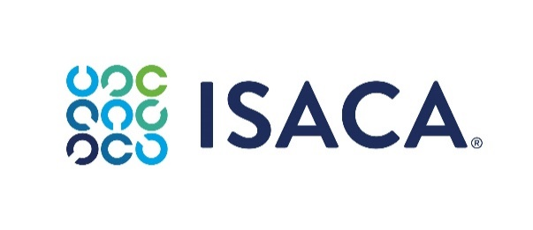
Form 1 – Report of Alleged Violation
To be submitted at ethics@isaca.org

Report of Alleged Violation Form
Confidential

Please read the ISACA Code of Professional Ethics - Member Ethics Violation Review Policy before completing and submitting this form.

Date of Submission:
Reporter – individual or entity submitting the Report of Alleged Violation.
If you wish to submit a Report of Alleged Violation anonymously,
please leave blank and follow the instructions below.
Name:
Address:
Phone Number:
Email Address:
Please note that if you provide your contact information, ISACA’s Ethics Manager may contact you to collect more information, as needed.
Subject – individual that is the subject of the Report of Alleged Violation.
Name:
Address:
Phone Number:
Email Address:

Description of Events
Please provide a date (or timeframe) and description of the event(s) related to the alleged violation(s) of the CoPE.

Are you aware of witnesses to the event(s) and can you provide their name(s) and contact information?

Are you attaching documents as evidence to support the alleged violation? If so, please describe what you are attaching and how the document(s) supports the allegation.

ISACA Code of Professional Ethics
Please indicate with an “X” which entry of the CoPE is at issue in the alleged violation you are reporting.
ISACA sets forth this Code of Professional Ethics to guide the professional and personal conduct of members of the association and/or its certification holders.
Members and ISACA certification holders shall:
- Support the implementation of, and encourage compliance with, appropriate standards and procedures for the effective governance and management of enterprise information systems and technology, including audit, control, security, and risk management.

- Perform their duties with objectivity, due diligence and professional care, in accordance with professional standards.

- Serve in the interest of stakeholders in a lawful manner, while maintaining high standards of conduct and character, and not discrediting their profession or the Association.

- Maintain the privacy and confidentiality of information obtained in the course of their activities unless disclosure is required by legal authority. Such information shall not be used for personal benefit or released to inappropriate parties.

- Maintain competency in their respective fields and agree to undertake only those activities they can reasonably expect to complete with the necessary skills, knowledge, and competence.

- Inform appropriate parties of the results of work performed, including the disclosure of all significant facts known to them that, if not disclosed, may distort the reporting of the results.

- Support the professional education of stakeholders in enhancing their understanding of the governance and management of enterprise information systems and technology, including audit, control, security, and risk management.

Please certify that the factual allegations made in this Response to the Investigation Summary are true and accurate to the best of your knowledge and are made in good faith.

Name:
Date:

